Test Simulationsmodell Wald

# Goal

The goal’s model is to produce a realistic workload for our experimental simulation system until the biologically founded real model is available.

# Time model

One Tick = One Day, 360 day / year, 30 days / month

# Model elements

## Tree

Is the center of the model. Can be a small seedling, small tree or a tall tree.

Attributes

|  |  |  |  |
| --- | --- | --- | --- |
| **name** | **type** | **value range** | **description** |
| id | Int | 0 - 2^32 | unique identifier |
| diameter | float | 0 < diameter | The diameter of the tree in m |
| height | float | 0 < height | The tree’s height in m |
| fitness | float | 0 < fitness < 100 | A value indicating the overall health of the tree (in %) |

Every tick a tree grows. Diameter and height growth are calculated separately.

### Growth calculation

d = diameter

h = height

GmaxH = maximum height

GmaxD = maximum diameter

GparK = growth coefficient

#### Diameter

#### Height

Parameters for Anogeissus leiocarpa: GparK = 0.18, GmaxH 15-30m, GmaxD=325/3.14

### Death

Can die of age (

### Seed dispersal

Seeds are dispersed in the period between April 15th and May 30th

Model: tree position is (approximate) center of 2-dimensional gaussian distribution

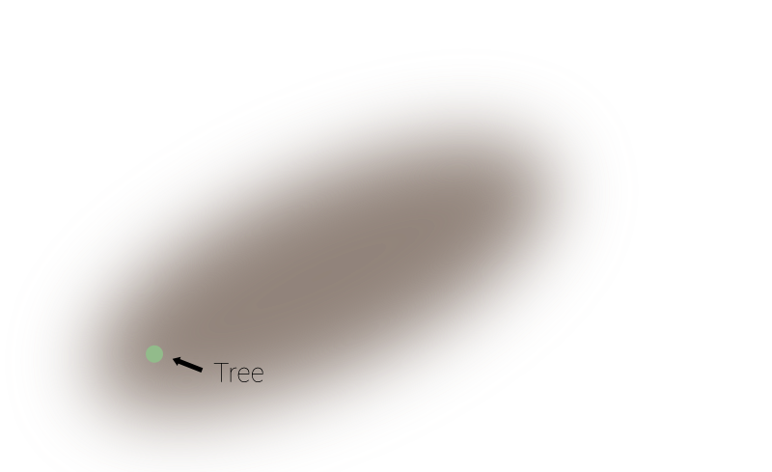

Success rate for ~1.5 mio. seeds 0.3% = ~45000 seeds spread

Generate positions using inverse transform sampling (solve for x) –>

(not exactly, dead spot around 0. Has to suffice for now :()